|  |  |  |
| --- | --- | --- |
|  | **Magic Mobility** | |
|  | Frontier x5 |

12 ½ x 2 ¼ drive wheels

The Frontier X5 is relatively maintenance free and not prone to breakdown.

Whilst it has been designed to be sturdier than a conventional wheelchair it is still a wheelchair and should be used with the appropriate care.

The typical maintenance inspection involves the checking of all moving parts (steering, wheels, free-wheeling, seating components) as well as batteries, battery charger and tyre pressures.

Should the chair be used in areas where it will be prone to moisture effects it would be wise to carry out maintenance checks more regularly. Please note that use in salt water will most likely cause substantial corrosion damage and should be avoided.

**Service Adjustments**

The Frontier has very few user/dealer replaceable or serviceable components. It is strongly suggested that suitably experienced technicians carry out any repairs that are required.

**Items that require some period checks are:**

**Tyre Pressures**: Check all grey Treaded pneumatic tyres have 40 psi of pressure.

**Castors**: Check all castors are rotate easily but are not too loose. Ensure that there is no build build-up of dirt, grease or other materials that could inhibit the free operation of the castors.

Check all Seating Components are secured.

The following components may require adjustment only if they have been removed or replaced

* Motor Brushes.
* Electromagnetic Parking Brakes.
* Joystick Module.

Motor Brush Adjustment

The Motor Brushes are located under each of the brush holder screw caps on each motor (4 on each).

On some heavy use chairs it may be necessary to clean out excessive brush dust. Using a medium pressure air gun blow clean air around and through the brush components. Take care not inhale the dust whilst doing this.

The brushes (there are 4 in each motor) may be removed by undoing the Brush Connection Screw and lightly pushing down and across on the Brush Clip. The Brush Clip and then the Brush will then lift up and out.

Electromagnetic Brakes

On some heavy use chairs it may be necessary to clean out excessive brake pad dust. Using a medium pressure air gun blow clean air around and through the brake components. Take care not inhale the dust whilst doing this.

Joystick Module

Should the Joystick Module be replaced at any time it must be replaced with either a pre-programmed unit or, alternatively programmed with the correct Frontier Dynamic DX Drive Program. To carry out this procedure it is necessary that the service facility be equipped with an appropriate computer, software and hardware (contact your local importer for information).

**Tyres**

The drive wheel tires used on the Frontier are standard wheelchair types. They need to be run at a pressure of 40 to 50 psi, under no circumstances exceed 50 psi

Exceeding this pressure will result in decreased wheelchair performance and can pose a serious safety risk.

PLEASE NOTE: It is not necessary to remove the complete tire to replace or repair the tube.

REPAIRING A FLAT TIRE (TUBE REPLACEMENT)

This procedure cannot be carried out with an occupant in the wheelchair.

Ensure that all of the air has been let out of the tire.

Place a block under the motor to hold the wheel in the air.

Remove the complete wheel from the wheelchair by undoing the single nut in the center of the wheel and sliding the wheel off the axle.

Using either plastic tire levers or simply by hand work the edges of the bead of the tire slowly down the rim (the warm soapy water helps here), this requires some effort and care must be taken NOT to bend or damage the rim.

Leaving the tire attached to the rim section on the inside, remove the tube from inside the tire.

Fit the new tube and re-assemble the wheel and to the chair using the reverse of the above procedure.

Inflate the tyre to 45 psi.

REPLACING A TIRE

This procedure cannot be carried out with an occupant in the wheelchair.

Ensure that all of the air has been let out of the tire.

Place a block under the motor to hold the wheel in the air.

Remove the complete wheel from the wheelchair by undoing the single nut in the center of the wheel and sliding the wheel off the axle.

The next part may be difficult and a bit of persistence and some hard labour will be needed.

It may be necessary to lubricate the inside of the deep rim section using a solution of warm soapy water.

If possible sit the flat center part of the rim on a wooden block to space the tire above the work area.

Using either plastic tire levers or simply by hand work the edges of the bead of the tire slowly down the rim (the warm soapy water helps here), this requires some effort and care must be taken NOT to bend or damage the rim

Once the old tyre has been removed a new replacement tire can be fitted using the reverse of the above procedure.

Inflate the tyre to 45 psi.

**Service Adjustments**

Important Note: Considerable damage may occur should the wheelchair be driven with any component faulty or damaged.

|  |  |
| --- | --- |
| CHAIR WILL NOT DRIVE. JOYSTICK STATUS LED FLASHING | Consult DX Flash Code section for further details. |
| CHAIR WILL NOT DRIVE STRAIGHT OR VEERS IN DIRECTION CONSTANTLY | Check all freewheeling paddles on all motors are engaged.  Lift all wheels off the ground and check for powered rotation on each wheel.  Should any wheel not rotate correctly check freewheeling operation and motor wiring/connector |
| CHAIR LACKS POWER | As above. |
| REAR MOTOR (one) FEELS SLUGGISH OR HAS A SQUEALING NOISE. | Remove domed brake cap on the effected motor and check the operation of the electromagnetic brake unit. |
| STEERING SLUGGISH | Check that both front wheels can pivot easily (lift the front of the chair off the ground to check this). Check that both the front and rear wheels have powered rotation. Check for correct tyre pressures. Heavier users may need slightly more tyre pressure (do not exceed 5psi) |
| CHAIR STOPS (STALL TIMEOUT) WHEN TURNING HARD ONE DIRECTION. | Ensure that the user is aware of the turn limitation of the Extreme. That is, the fixed turning circle – exceeding this will stall the motors and cause the chair to shut down. |
| BATTERIES GO FLAT VERY QUICKLY OR RANGE IS VERY LIMITED. | Check battery charger for correct operation. Check batteries capacity. |
| CHAIR JERKS WHEN MOVING SLOWLY.  MOTOR RUNS BUT WHEEL DOES NOT TURN OR TURN INTERMITTENTLY | Check batteries. Check all motor brushes for excessive wear and or scoring or arcing. Check that all motor brushes move freely in the brush holders (ie not seized). |
| CHAIR TURNS ON BUT WHEN JOYSTICK IS MOVED NOTHING HAPPENS AND DX STATUS LED ON JOYSTICK FLASHES. | Check freewheeling paddles operate correctly. Check wheel hub and keyway on axle shaft for damage. Possible gearbox problem, check worm wheel in gearbox. |

**Flash Codes**

Any fault condition on the DX system will cause the RemG80’s System Status LED to flash. Flashing occurs in bursts of flashes separated by a two-second pause.

The number of flashes in each burst is referred to as the Flash Code and indicates the nature of the fault.

The title of the Flash Code fault is also displayed by the HHP if connected to the faulty wheelchair.

Faults that effect the safety of the chair will cause the chair to stop while less critical ones will be indicated but allow the chair to continue driving. Some faults will automatically clear when the fault condition is removed, in which case the System Status LED will become steady and the wheelchair may be driven normally.

Others faults are latched and must be cleared by turning the DX System off, waiting for two seconds, turning it back on again.

FLASH CODE 1 - DX Module Fault (see Limp Mode below)

Cause: An Auto Download has occurred.

Action Turn the REMG80 off then on again.

Cause: The REMG80 is not correctly programmed.

Action Try reprogramming the REMG80.

Cause: Connection between DX Modules may be faulty, or there may be an internal fault in a Module.

Action Check DXBUS connections and replace where necessary.

If the Status LED on another Module is flashing, replace the Module. An expected module may not be present (e.g. the DX Lighting Module).

FLASH CODE 2 - DX Accessory Fault

Cause: There is a fault in an accessory device attached to a DX Module (excluding the PM). Examples of faults in accessory devices may be : the clutch is, or has been, disengaged; a light bulb is short or open circuit; an actuator terminal is shorted to Battery +.

Action Check all accessory devices connected to your DX System.

FLASH CODE 3 - Left (M1) Motor Fault

Cause: The connection from the PM left (M1) connector to its associated motor, or the motor itself, is defective. The connection is either open or short circuit.

Action Disconnect the left motor plug and check continuity between the motor pins on M1.

FLASH CODE 4 - Right (M2) Motor Fault

Cause: The connection from the PM right (M2) connector to its associated motor, or the motor itself, is defective. The connection is either open or short circuit.

Action Disconnect the right motor plug and check continuity between the motor pins on M2.

FLASH CODE 5 - Left (M1) Park Brake Fault

Cause: The M1 plug connection to its associated Park brake is either open or short circuit. Action Disconnect the M1 plug and check continuity between the two Positronic park brake pins.

FLASH CODE 6 - Right (M2) Park Brake Fault

Cause: The M2 plug connection to its associated Park brake is either open or short circuit.

Action: Disconnect the M2. plug and check continuity between the two Positronic park brake pins.

FLASH CODE 7 - Low Battery Fault

Cause: The battery charge is not sufficient to allow safe driving. It has fallen below 17V

Action Check battery connection and terminals. The battery voltage should be similar when the battery is on charge, and when it isn’t. Check that fuses have not blown, or circuit breakers tripped. Replace battery if worn out or if capacity is insufficient for the user’s needs.

Note: The wheelchair will behave sluggishly and the Battery Gauge will flash indicating low battery voltage prior to the display of this fault.

FLASH CODE 8 - Overvoltage Fault

Cause: The battery voltage has exceeded 32V.

Action If this fault occurs during battery charging, the battery charger is defective or incorrectly adjusted. Check the battery chargers open circuit voltage is in accordance with the battery manufacturers limits, and is less than 32V.

Cause: The battery connector is making intermittent contact when the wheelchair is stopped, or travelling down a slope.

Action Check that the battery wiring and terminating is secure.

FLASH CODE 9 - CANL Fault (see Limp Mode below)

Cause: 1. An invalid voltage has been detected on the DXBUS CANL line.

Cause 2. Communication is not possible using the CANL wire.

Action Check the continuity of the DXBUS cable. Check for shorts between DXBUS pins. An open or short circuit on another DX Module can cause this fault.

FLASH CODE 10 - CANH Fault (see Limp Mode below)

Cause: 1. An invalid voltage has been detected on the DXBUS CANH line.

2. Communication is not possible using the CANH wire, or the CANH and CANL wires are shorted together.

3. Hazard lights were turned on when the DX System was turned on.

4. The CANH is used to generate a Kill signal by any DX Module which detects an unsafe condition, or by an external device such as an emergency stop switch. The CANH wire is pulled to either Battery + or Battery - and causes the DX System to shut down.

Action Check the continuity of the DXBUS cable. Check for shorts between DXBUS pins. An open or short circuit on another DX Module can cause this fault. If the Hazard Lights were already switched on when the DX System was turned on, Flash Code 10 and Limp Mode (slow driving) may result. To clear this fault, turn the Hazard Lights off, then turn the DX System off then on again. If generated by a Kill signal, the cause of the fault is severe.

FLASH CODE 11 - Stall Timeout Fault

Cause: The motor current has been at, or close to, current limit for longer than the Stall Timeout parameter value.

Action Turn the DX System off then on again.

FLASH CODE 12 - Module Mismatch

Cause: There is a compatibility problem between DX Modules in the System. The wheelchair will be disabled.

Cause: The data held by the REMG80 for another DX Module is corrupt or incompatible with that module.

Action Reprogramming the wheelchair system may correct this problem.

Limp Mode

If the DX System detects some faults, it will revert to Limp Mode. This is a reduced speed mode which recognises problems, but allows the wheelchair user to limp home, where the problem can be assessed.

Some examples of Limp Mode are:

*DX Power Module EPROM Fault*

On detection of this fault, all speed parameters are reduced to one half of their programmed value; the Current Limit is reduced ; and the Load Compensation is set to zero. This may occur with Flash Code 1, and the PM Status LED will also flash.

*DX Remote (UCM) EEPROM Fault*

On detection of this fault, the Joystick Calibration is set to a known and low gain value, giving lower maximum speed. Load Compensation and Current Limit are not affected. This fault will also cause Flash Code 1 to be displayed, and the RemG80’s Remote Status LED will also flash.

*Communications Fault*

If the DXBUS goes into single wire mode (CANL or CANH are unstable or shorted), all speed parameters are reduced to one half of their programmed value. This may occur with Flash codes 9 and 10.

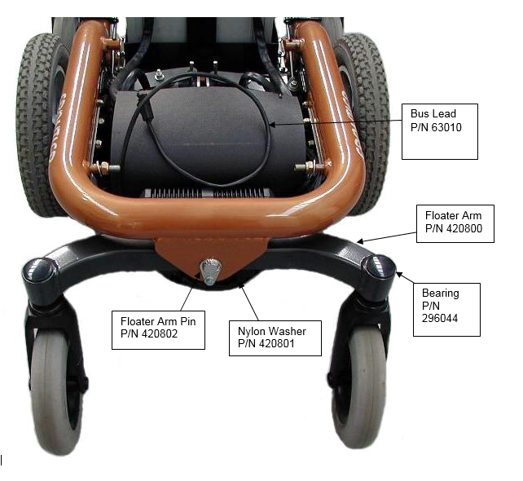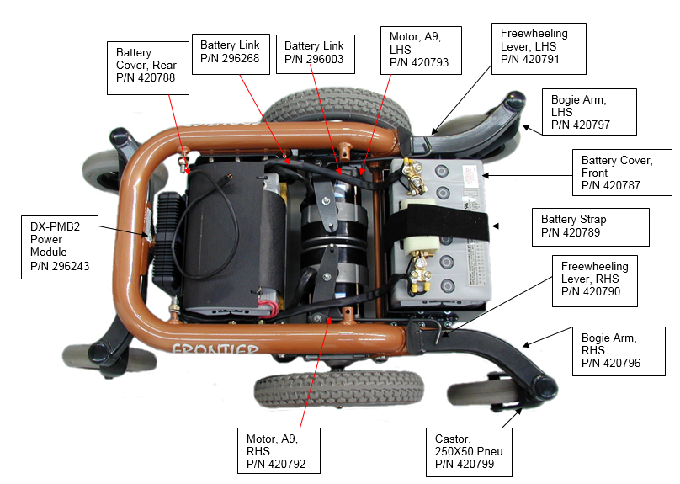

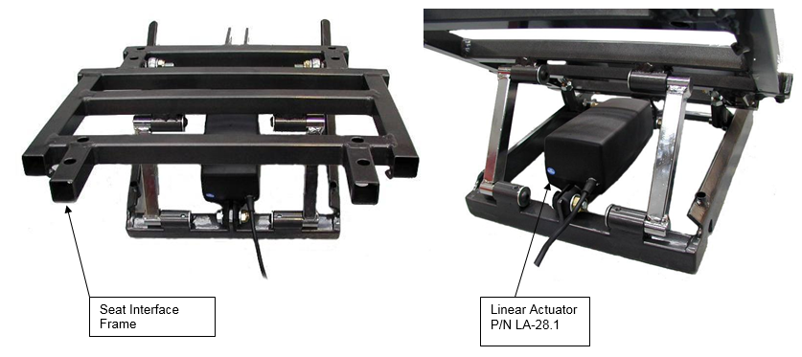

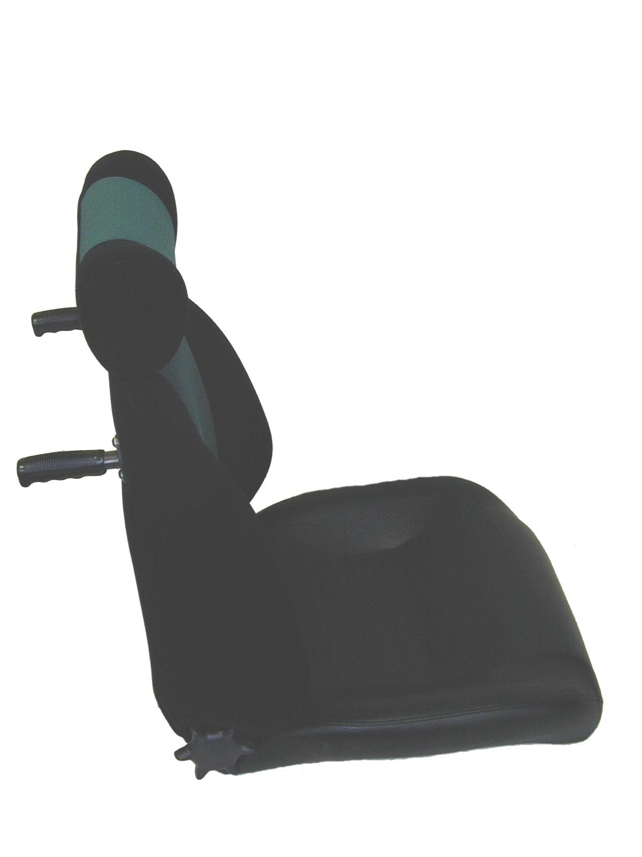

Recline Handwheel

P/N 296284

Recline Mechanism

P/N 296281

Bolt, 8mmX20mm

P/N 296117

Nylock Nut, 8mm

P/N 296121

Push Handle, Peg

P/N 296282

Seat, MPS, complete

P/N 296147

Nylock Nut, 8mm

P/N 296121

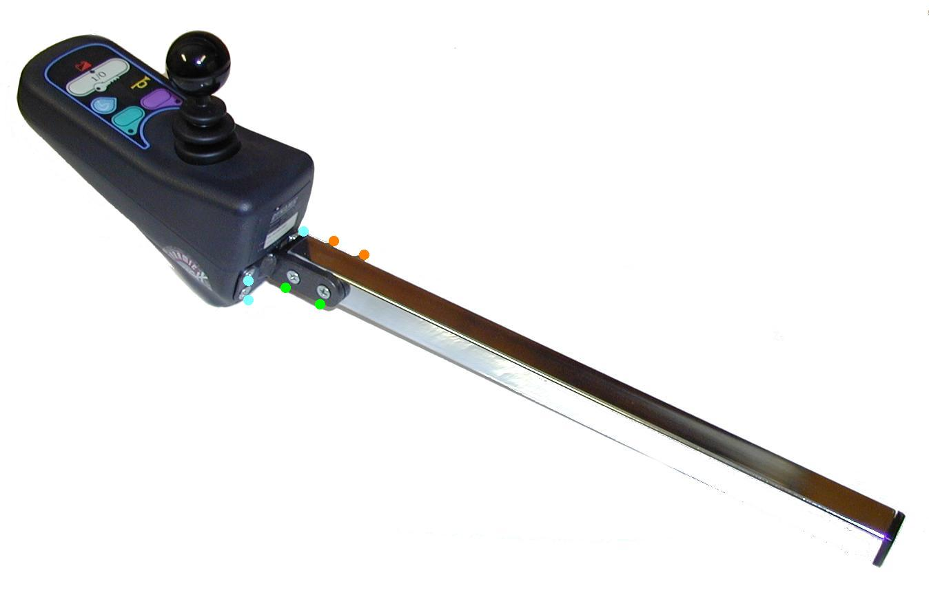

Screw, 5mm X 12mm

P/N 296111

Chrome Stem

P/N 296107

Nylock Nut, 5mm

P/N 296105

DX-REMG80 Joystick

P/N 296102

Screw, 5mm X 30mm

P/N 296109

Europa Mount

P/N 296108

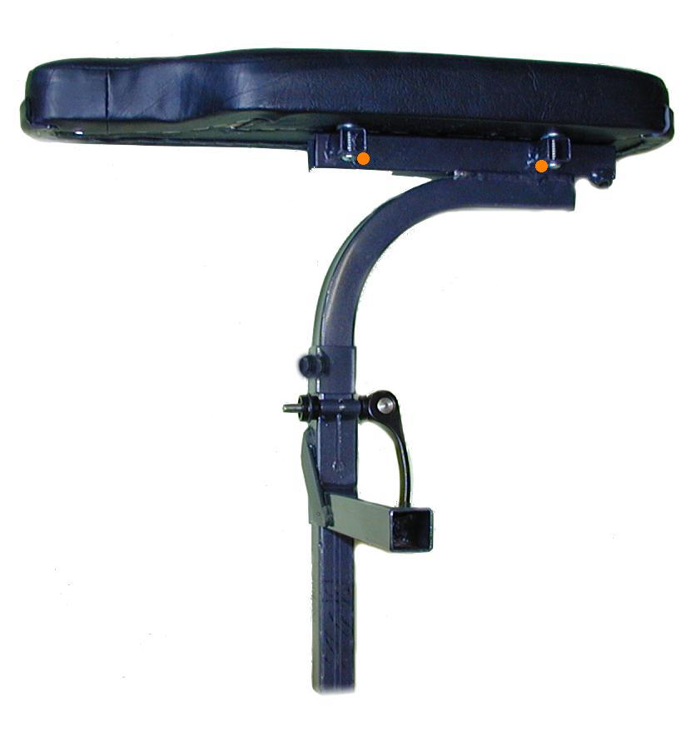

Armrest Elbow

P/N 296173

Camlock

P/N 296175

Armrest Pad (L or R)

P/N 296075 + 296076

Grub Screw, 6mm X 8mm

P/N 296085

Armrest

P/N 296081

Screw, 3/16” X 1”

P/N 296077

Nylock Nut, 6mm

P/N 296169